NHE 2026 Competition Results

First Place overall NHE winner:
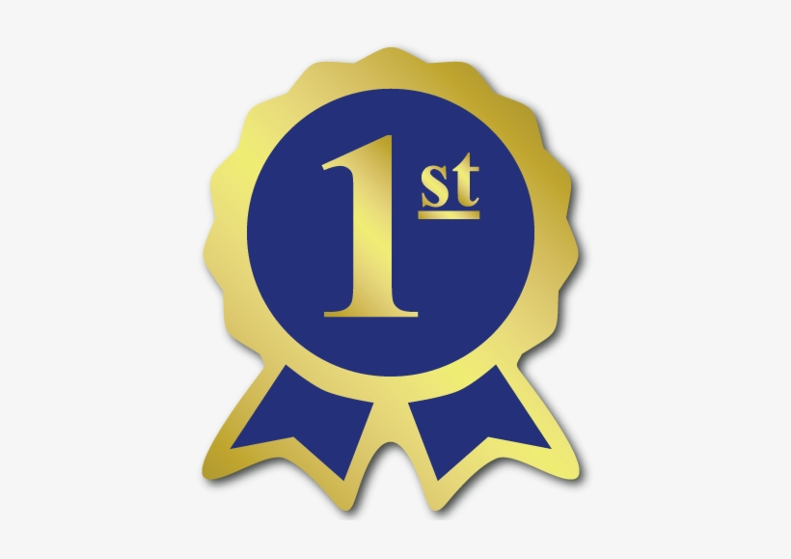
Timberlane team 20!

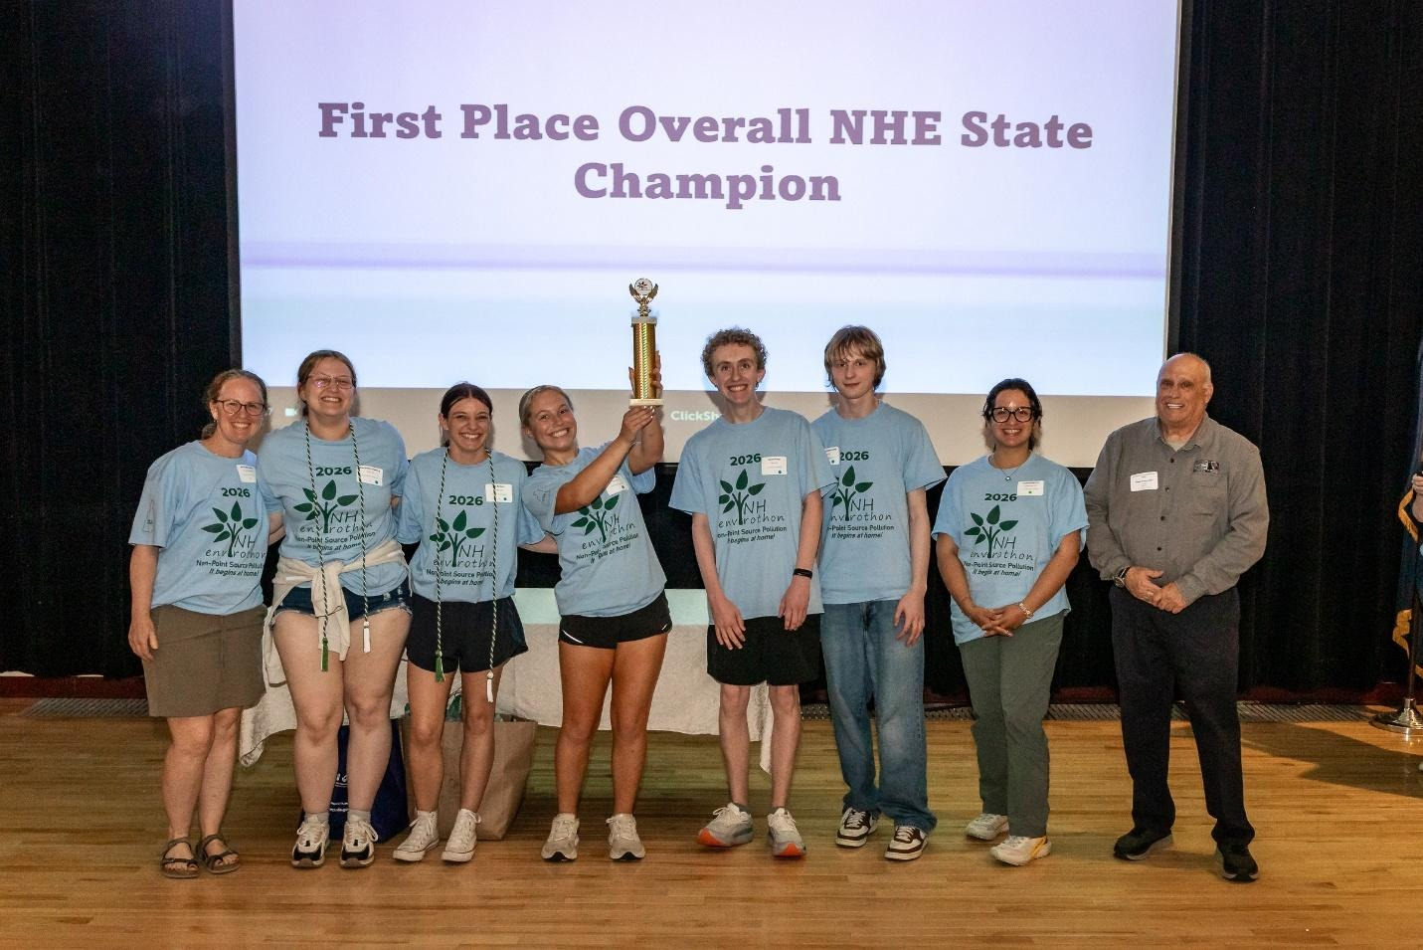

Timberlane team 20 also placed first in Aquatic Ecology.

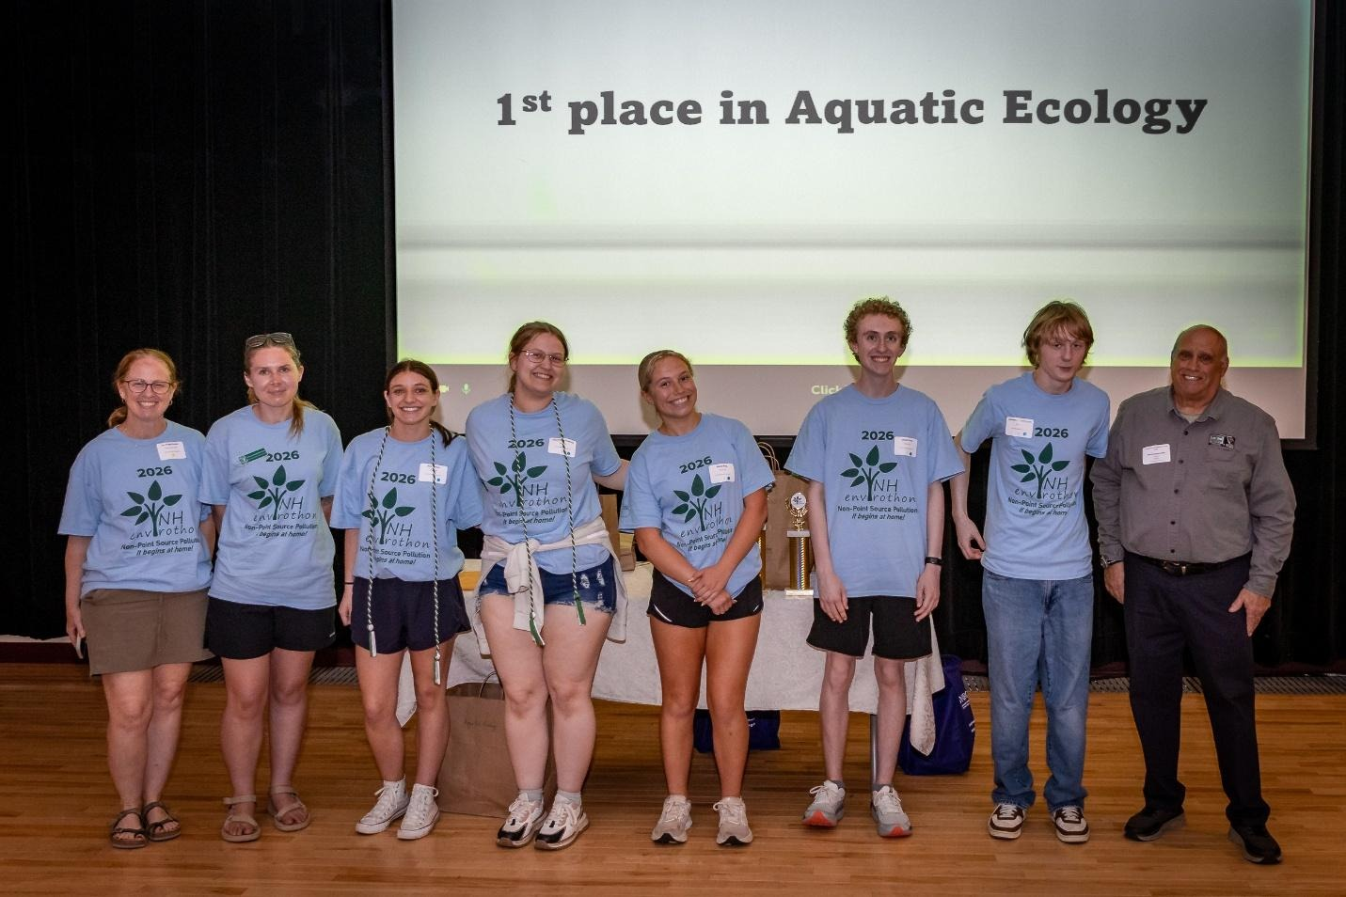

Timberlane team 20 also placed first in Aquatic Ecology and Soils & Land Use.

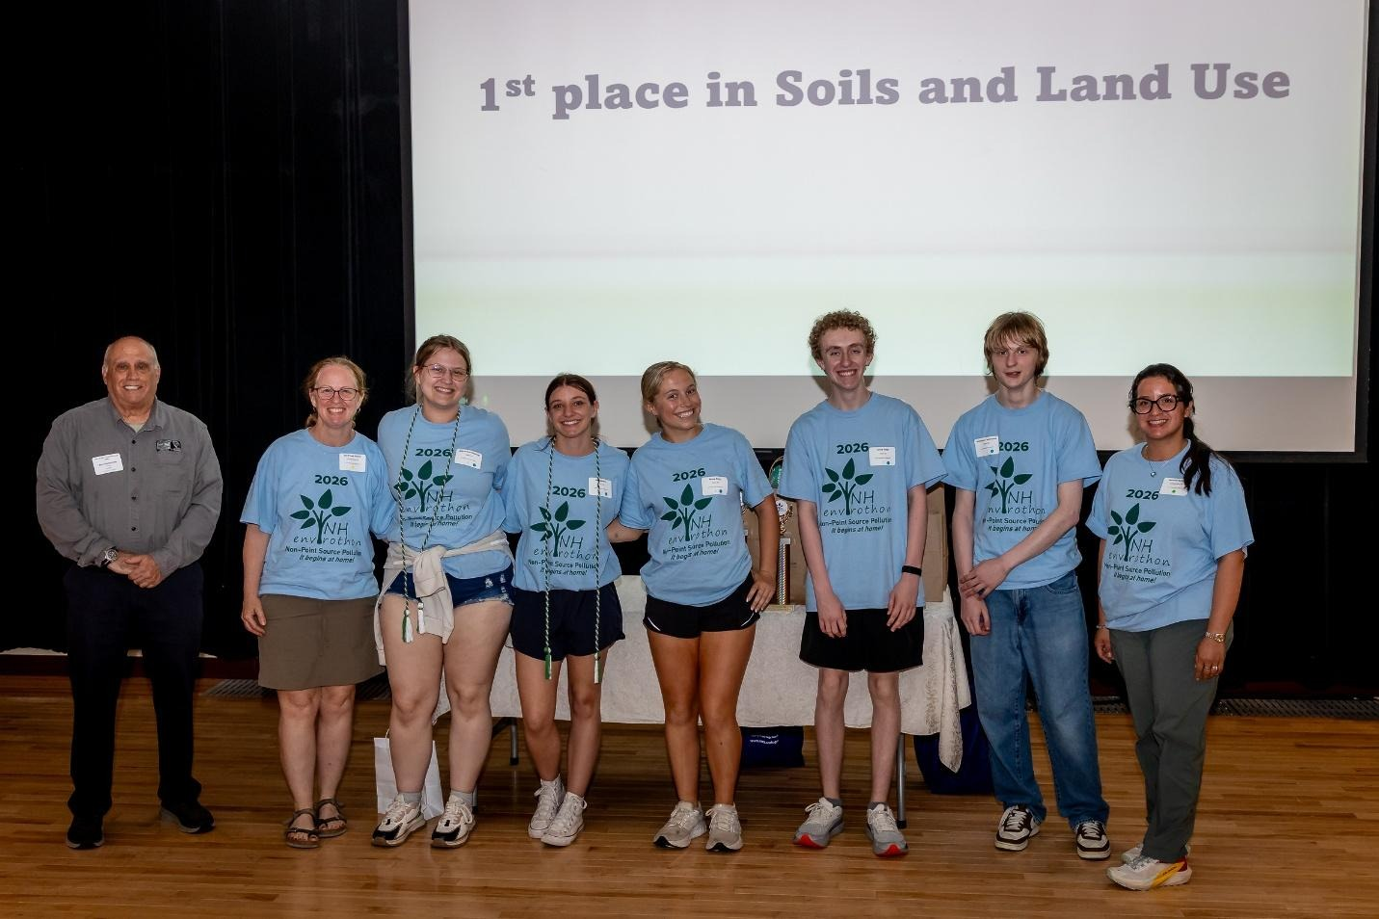

Timberlane HS represented NH at the International NCF Envirothon in Mississippi this July.

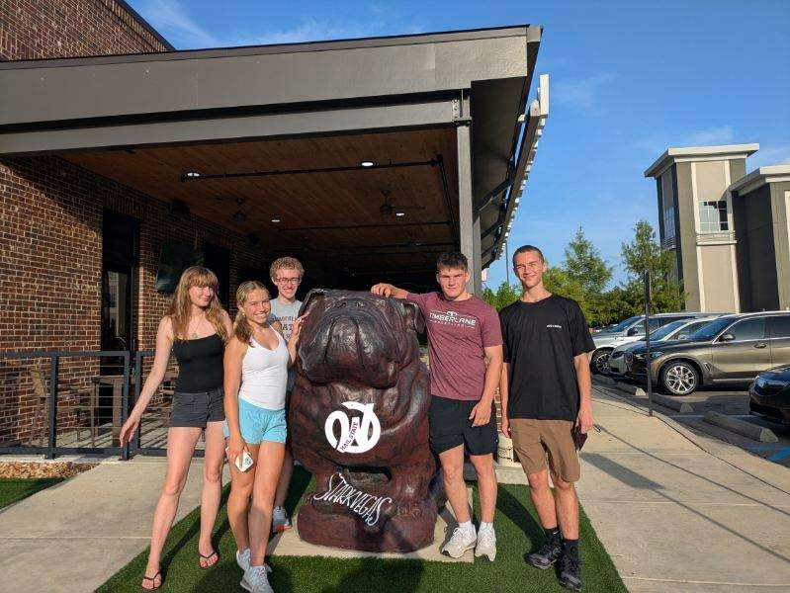

Second Place overall:
Keene High School, team 11!

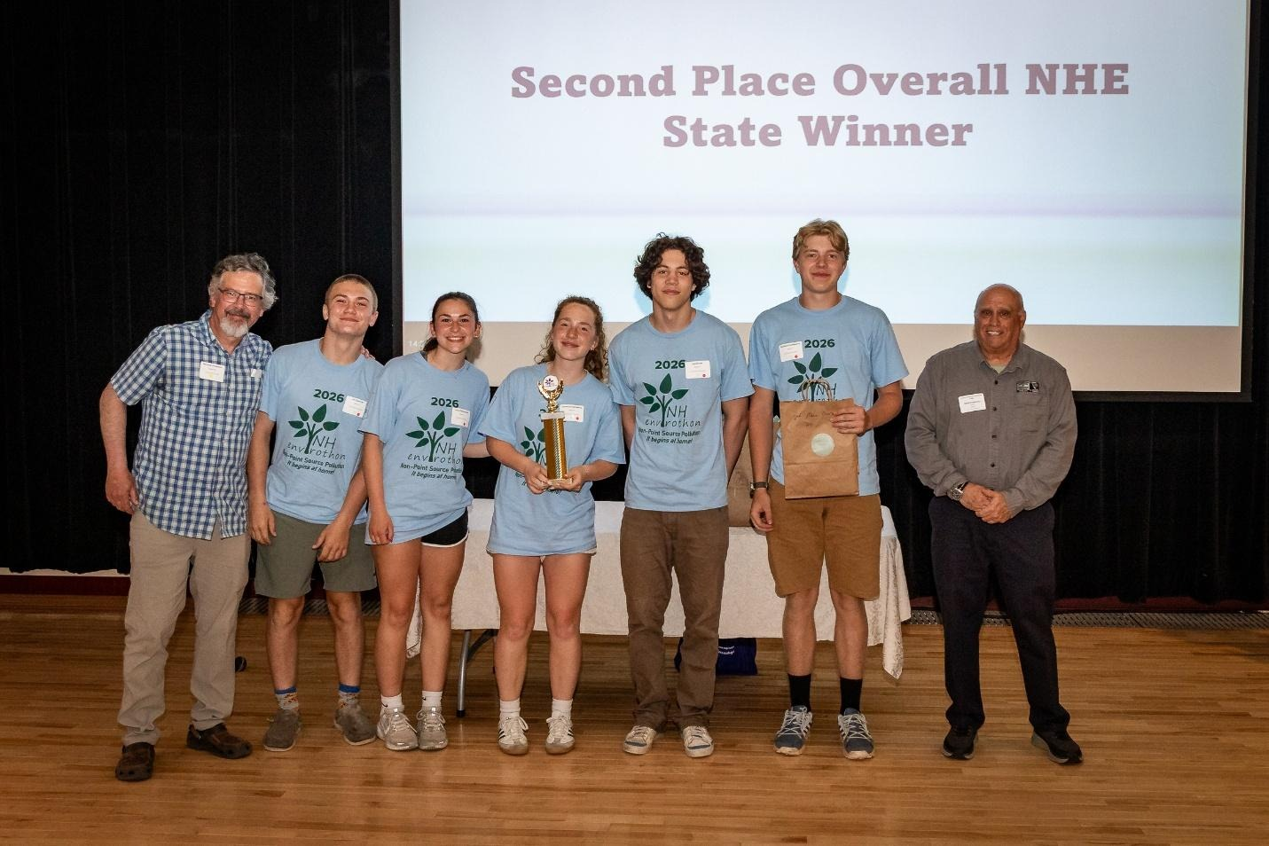


Third Place overall:
Goffstown High School, team 8!

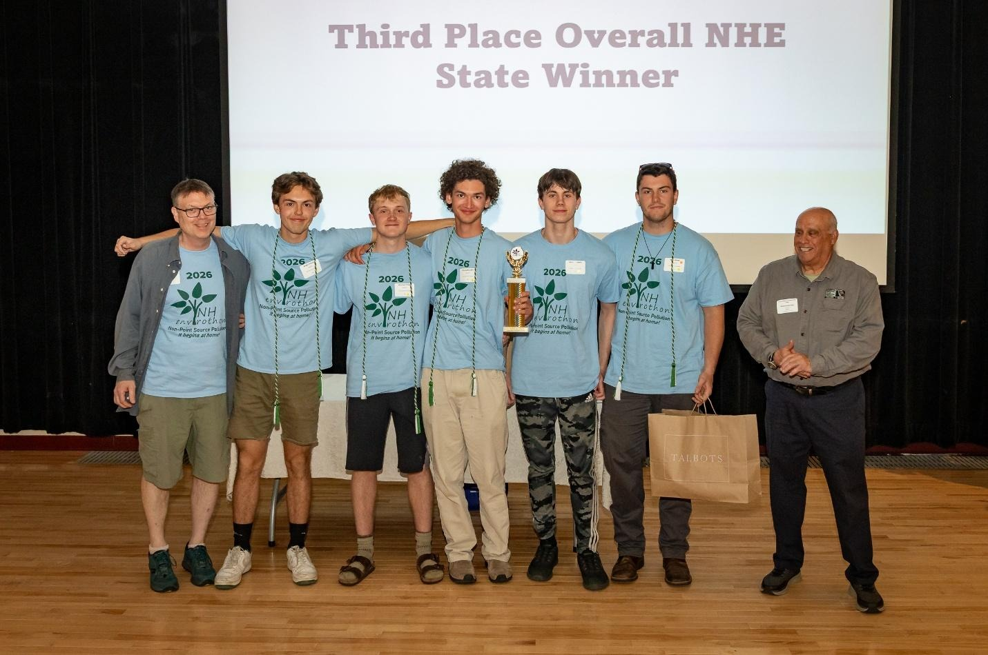
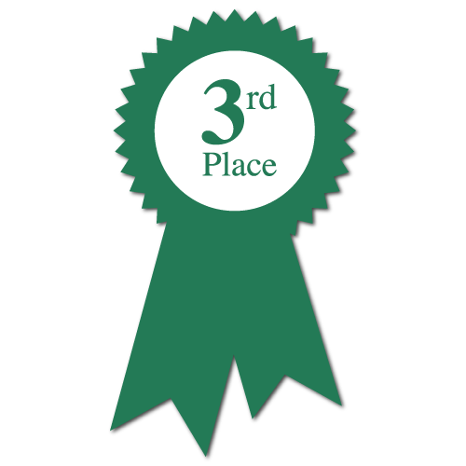

Goffstown, team 8.was also first in Forestry and Wildlife.

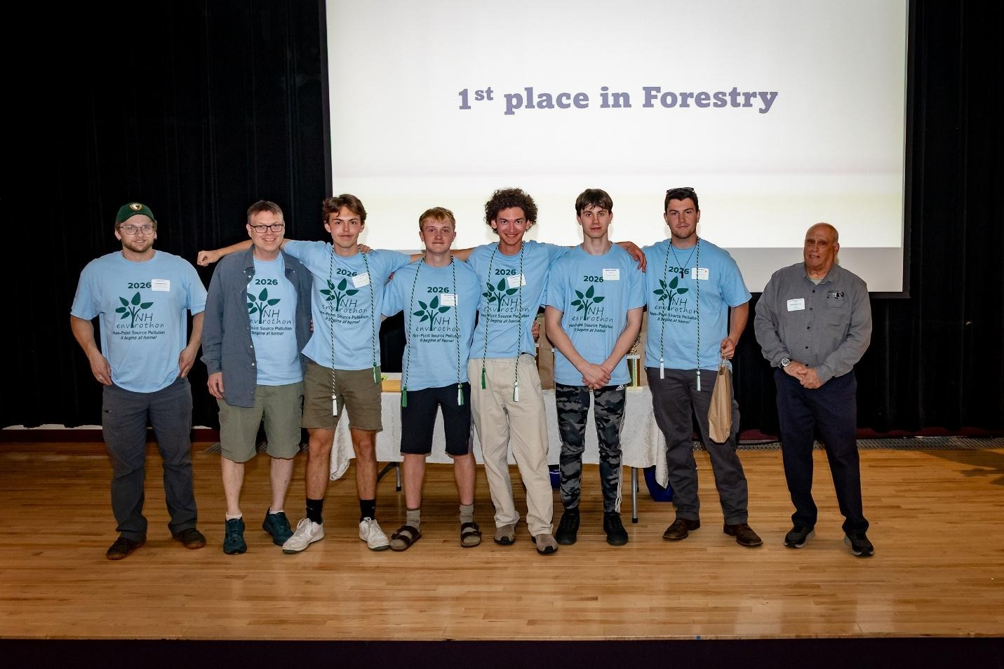

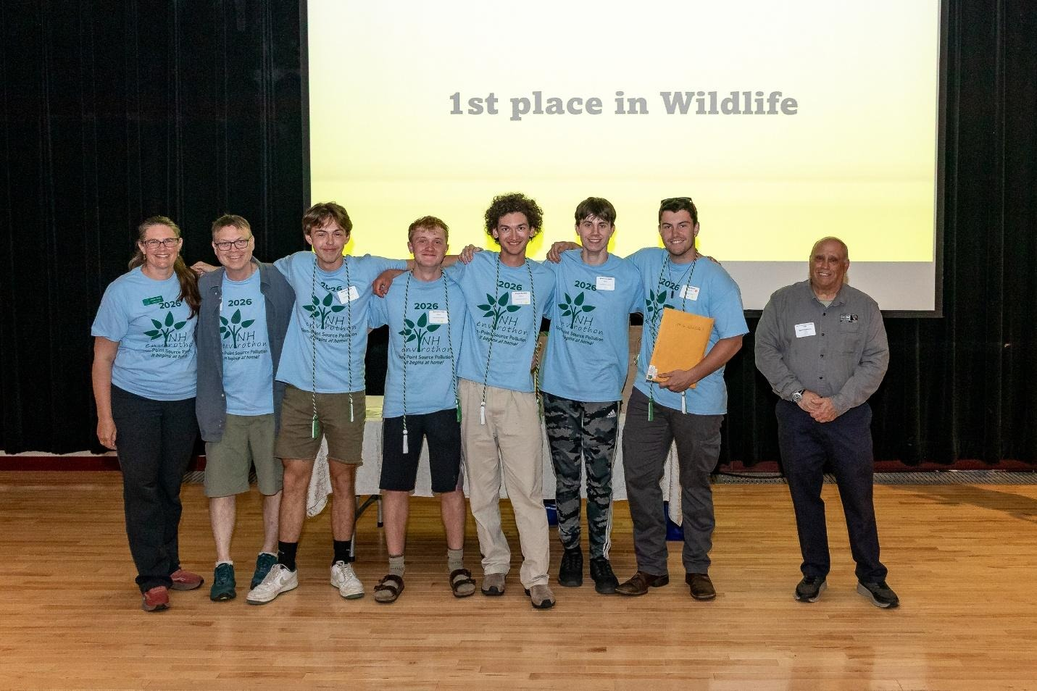

Sanborn 16 won the Current Environmental Issue station.

No photos are available yet

Middle School Winners
Moultonborough MS, team 24 (1st)
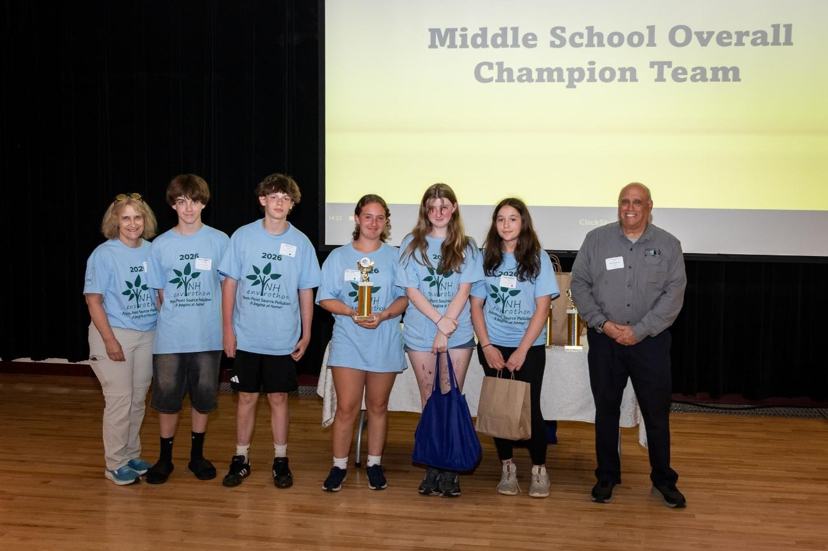
Moultonborough MS, team 25 (2nd)
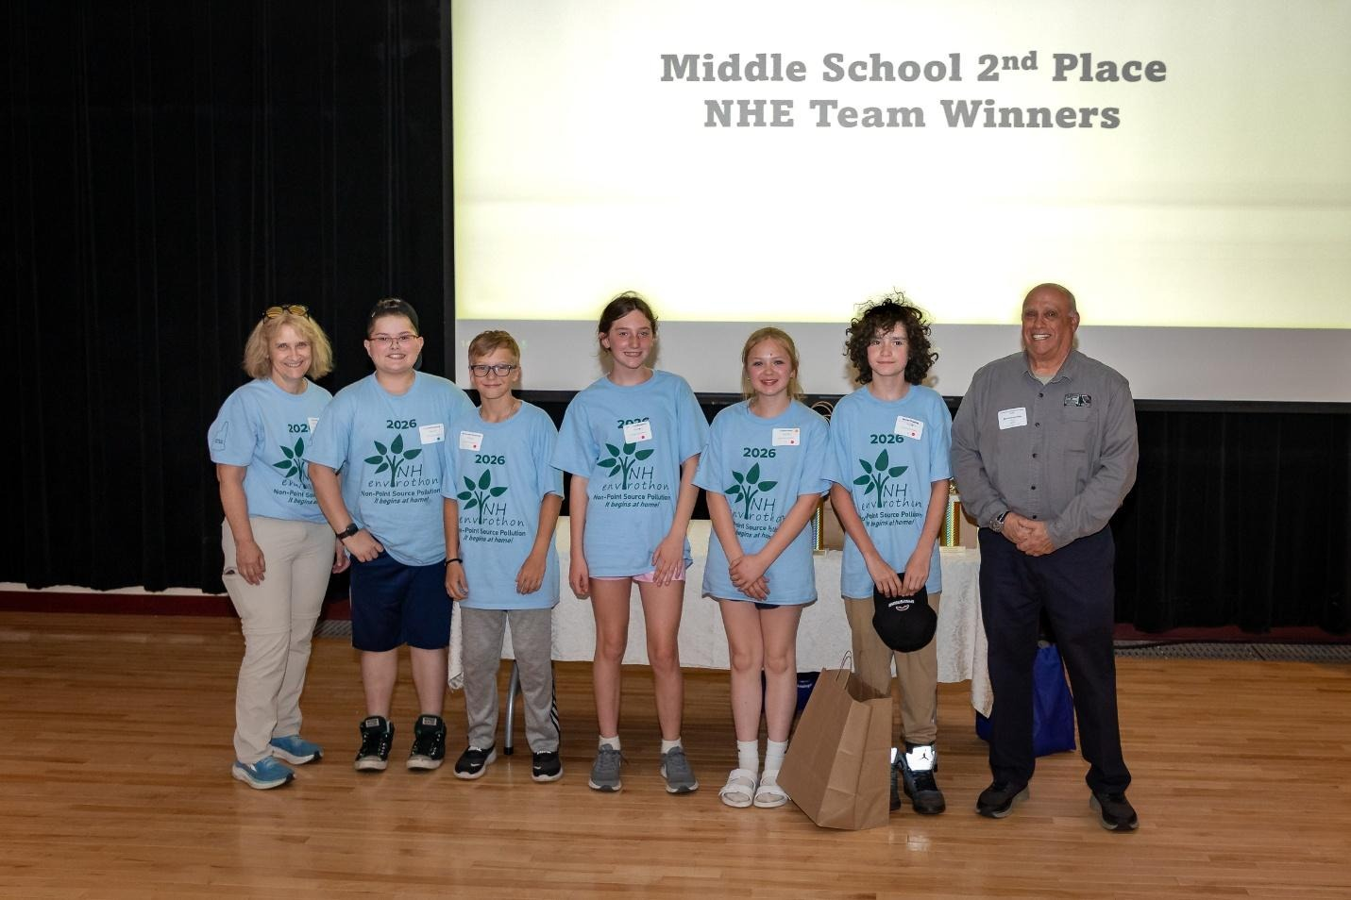
Congratulations to ALL NHE participants!

