Town Parcel Information for April 2025 NHE Webinar
Preface: The following lot description is a parcel that is part of a larger town forest found in the town of Granite Cliffs, NH. A town forest is defined specifically by State Law and was voted as a Town Forest at Town Meeting. A town forest’s purpose is defined in NH RSA 31:111 as, “The main purpose of such city or town forest shall be to encourage the proper management of timber, firewood and other natural resources through planting, timber stand improvement, thinning, harvesting, reforestation, and other multiple use programs consistent with the forest management program, any deed restrictions and any pertinent local ordinances or regulations.”
Lot Description:
The overall lot includes four tree stands numbering 9-12. Each stand has 68, 46, 30, 44 acres respectively and is composed of respective tree types of POM, Wp, Wp-He, POH. Where: Wp= White pine, POH = Pine-oak-hemlock, POM = Pine-oak-maple, He =Hemlock.
The forest is a combination of mature timber, primarily white pine, red oak, and American beech, with intermediate pole-sized timber approximately 10-15 inches in diameter composed of red oak, black birch, and American beech. The parcel has some areas of steep slopes and difficult terrain.
This parcel contains the height of land at 1050 feet above sea level. The center of the property is the ledge outcrop that forms the peak of a mountain. This area, surrounded by additional conservation lands, contains a block of mature forest and is frequently enjoyed by town hikers. The four parcel ages are 60/90, 90, 90, 60/90 years, respectively.
This parcel also contains forested wetlands, seasonal streams, snags, cavities, and down logs. There are scattered stems of mature timber. These scattered “older growth” stems contain large cavities and have expansive crowns producing hard mast. Most of these stems are red oak or white pine. Wooly adelgid has been evidenced on the parcel’s hemlocks (Tsuga spp.).
Access for this parcel is accessible using existing hiking trails, Class A trails, and Class VI roads. Boundary lines are well marked by stonewalls, blazes, paint, and Town Forest signage.
Potential wildlife includes the Blue-spotted salamander, bald eagle, Jefferson salamander, Spotted turtle, Canada warbler, Bobcat Cooper’s hawk, Wild turkey, Northern goshawk, Wood thrush, Wood turtle, Veery, American woodcock, Black racer, White-tailed deer, Moose, Black bear, Blanding’s turtle, Ruffed grouse, and Snow-shoe hare.
Bittersweet, multi-flora rose, barberry, buckthorn, burning bush, honeysuckle, and autumn olive are species that have been identified and/or likely nearby or capable of occurring.
The most common soil type within the properties and across the landscape is Chatfield Hollis-Canton complex. This soil has slopes that range from 3-8% and 8-15%. These soils are very stony, well drained, derive from glacial till, and are part of Important Forest Soil Group IB. Very small parcels towards the property edges include Paxton 67B 67C IA, Montauk 45C 45D IA, and Canton 43D IB soils as well.

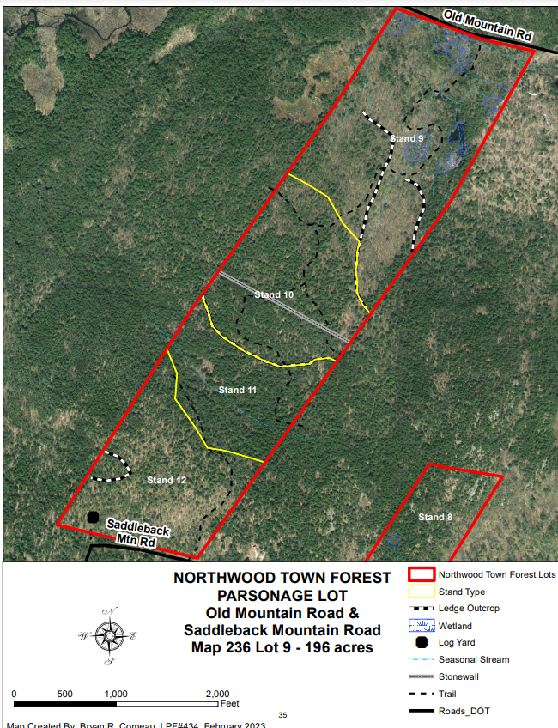
123
Town lot
Granite Cliffs
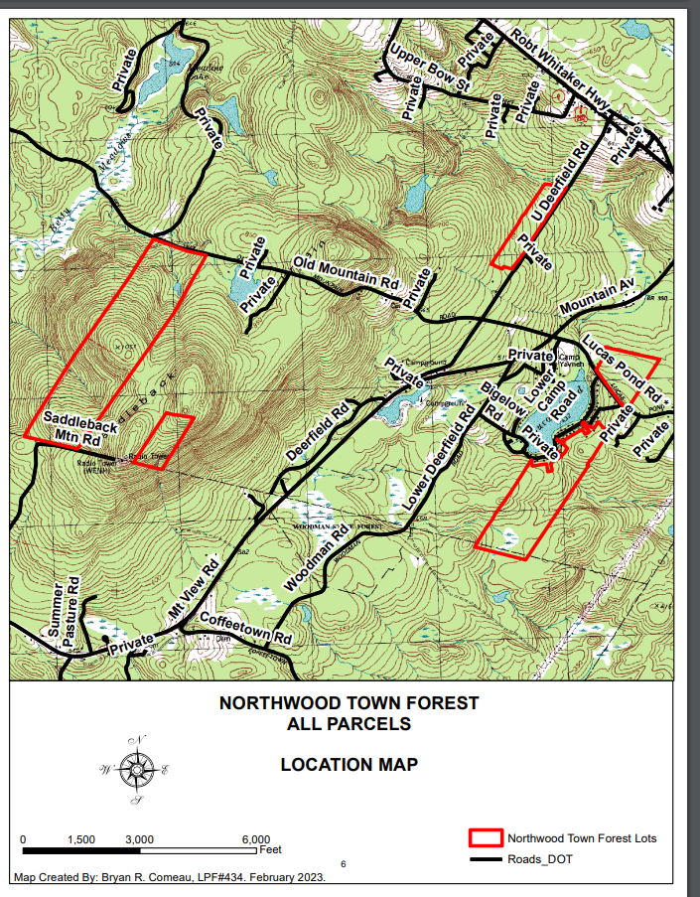

Map of the HUC12 Watershed Boundary
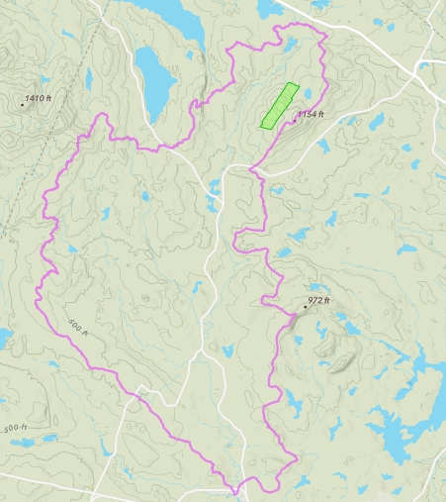
Parcel of stands 9-12 is shown in green.
The watershed boundary is shown in pink. (This watershed is also the headwaters of a major river.)

Close up View of Parcel and Watershed
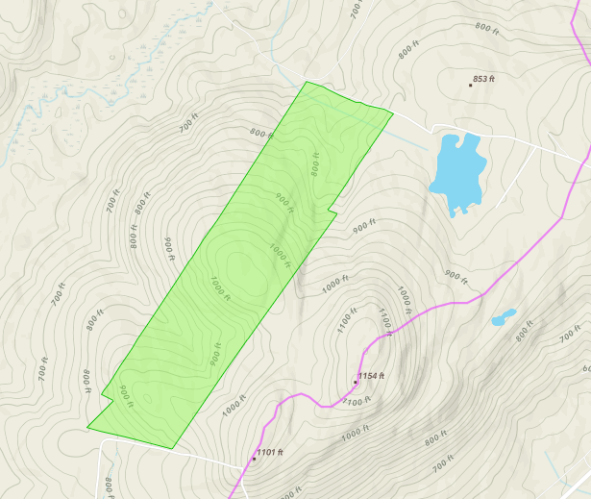

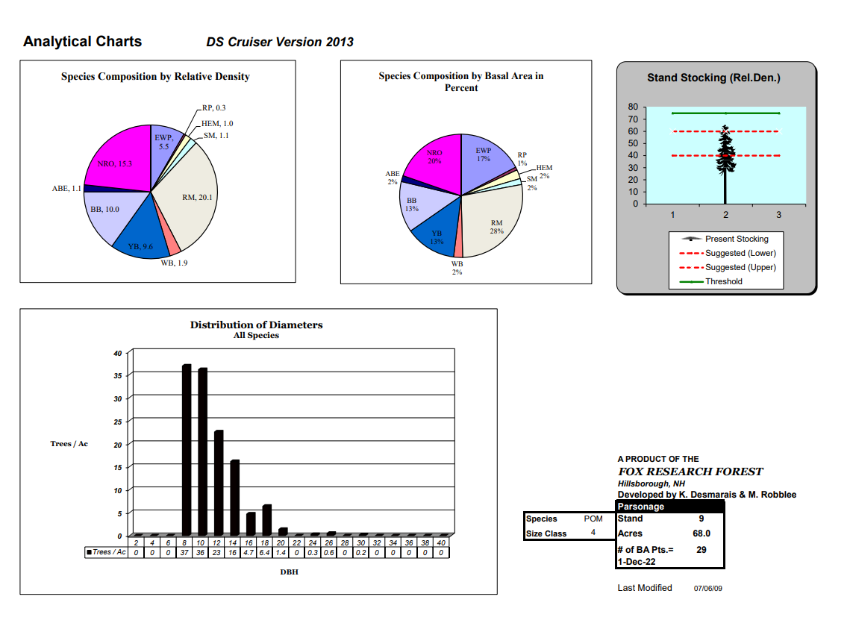
Stand 9:

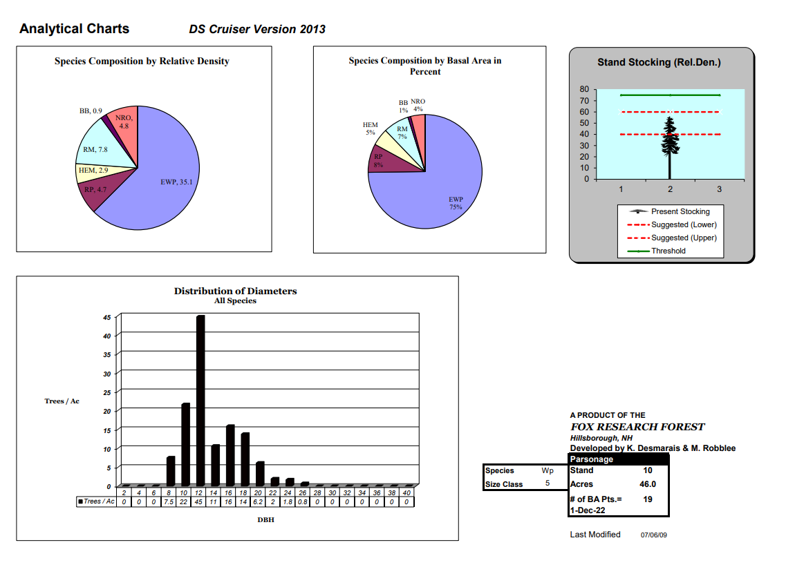
Stand 10

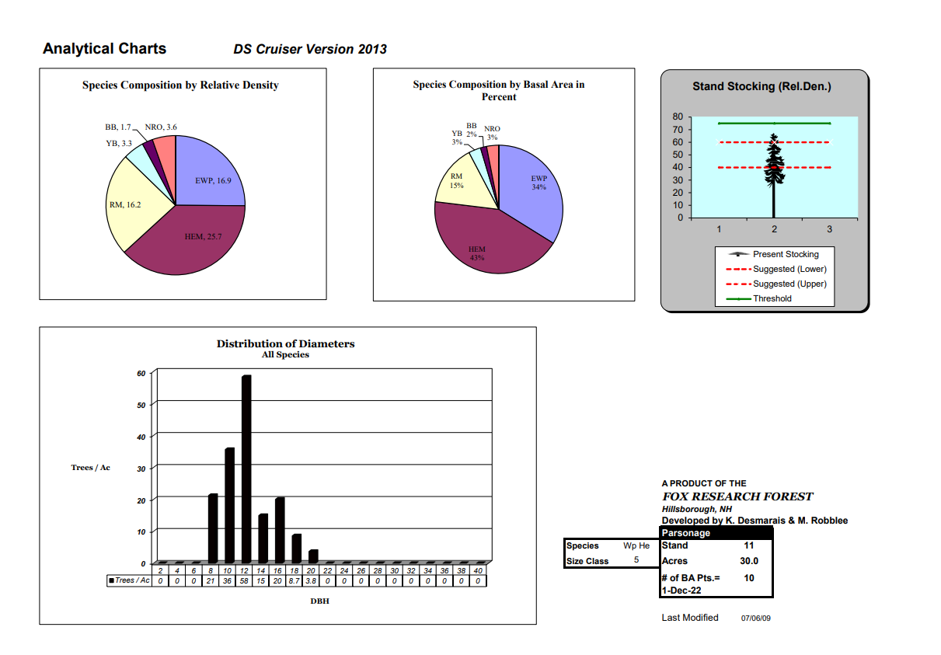
Stand 11

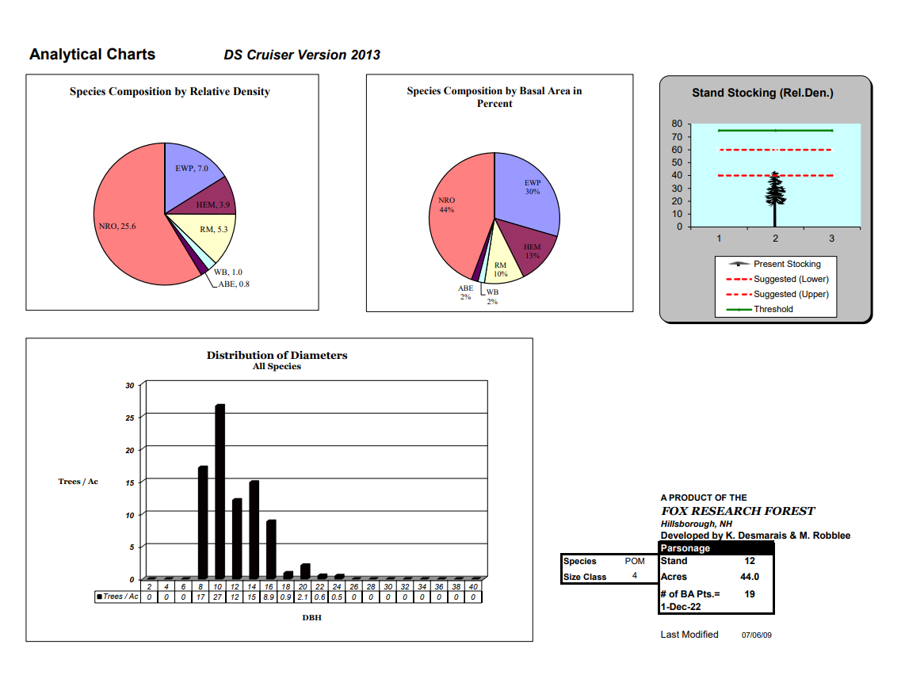
Stand 12

Key to Tree Specie Abbreviations:
RP – Red Pine
EWP – Eastern White Pine
HEM – Eastern Hemlock
SM – Sugar Maple
RM – Red Maple
WB – White Birch
YB – Yellow Birch
BB – Black Birch
ABE – American Beech E?????
NRO – Northern Red Oak

