NH Envirothon 2025
Category | Winning Team
Aquatic Ecology | Timberlane – team 20
Current Environmental Issue | Goffstown – team 7
Forestry | Timberlane – team 20
Soils and Land Use | Merrimack – team 10
Wildlife | Goffstown – team 17
2nd place Middle School | Moultonborough – team 4
1st place Middle School | Moultonborough – team 3
1st place Vermont HS | Woodstock Union – team 1
3rd place NH HS | Goffstown – team 17
2nd place NH HS | Timberlane – team 20
1st place NH HS | Goffstown – team 7
Schools participating:
Alvirne HS, 2 teams
ConVal HS, 2 teams
Fall Mountain HS
Goffstown HS
Keene HS
Kingswood HS
Merrimack HS
Sanborn HS
Stevens HS
Timberlane HS
Vermont Team
Woodstock Union HS
Kingswood MS
Moultonborough MS
115 Total Students

Venue – Squam Lakes Natural Science Center, Holderness, NH on 5/19/25.

1st place overall HS 2nd place overall HS
Goffstown, team 17 Timberlane, team 20
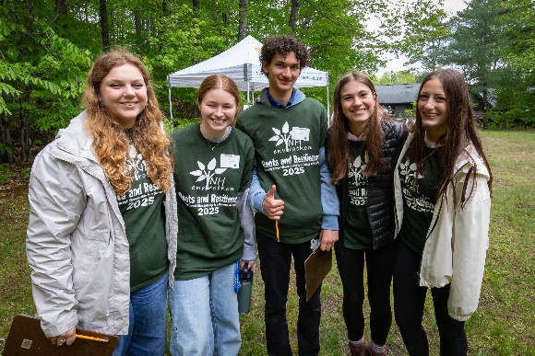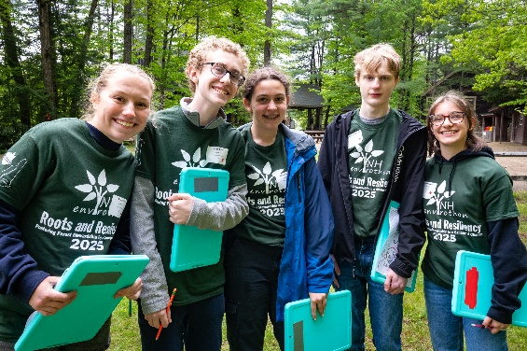

3rd place overall HS 1st place Vermont HS
Goffstown, team 7 Woodstock Union, team 1
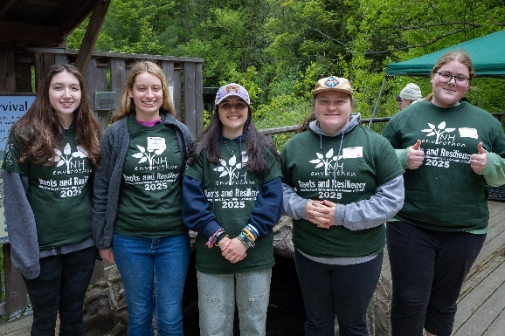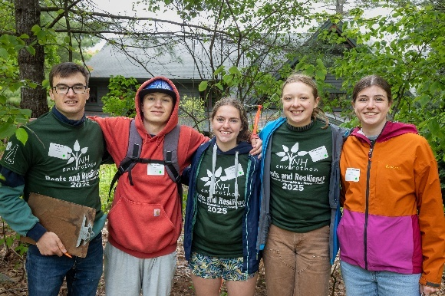
1st in Aquatic Ecology 1st in Current Environmental Issue
Timberlane, team 20 Goffstown, team 7
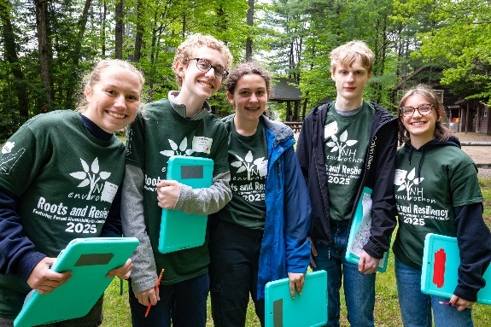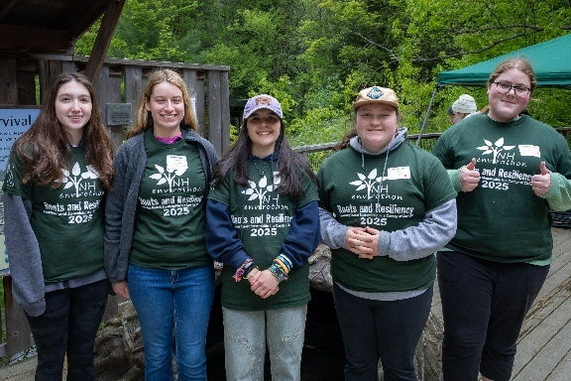

1st in Forestry First in Soils and Land Use
Timberlane, team 20 Merrimack, team 10
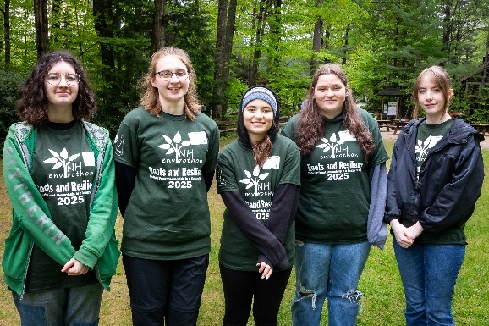

1st in Wildlife
Goffstown, team 17
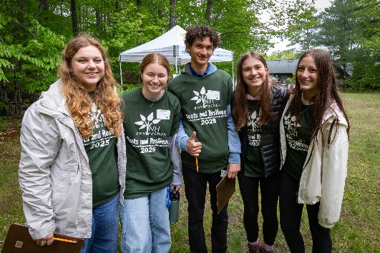

1st place Middle School 2nd place Middle School
Moultonborough, team 3 Moultonborough, team 4
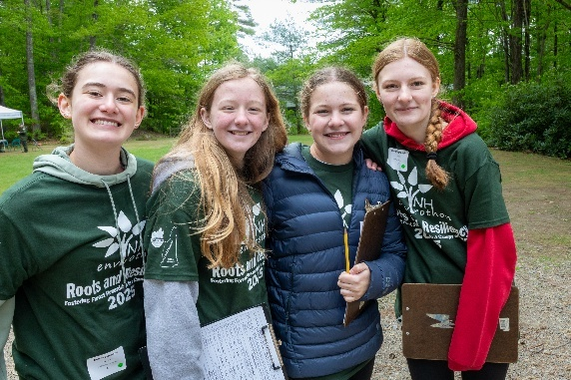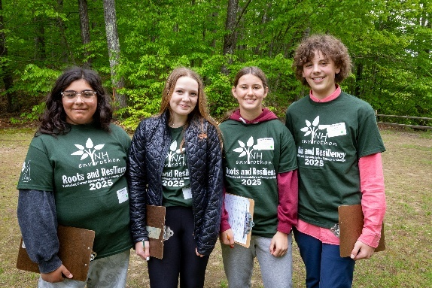

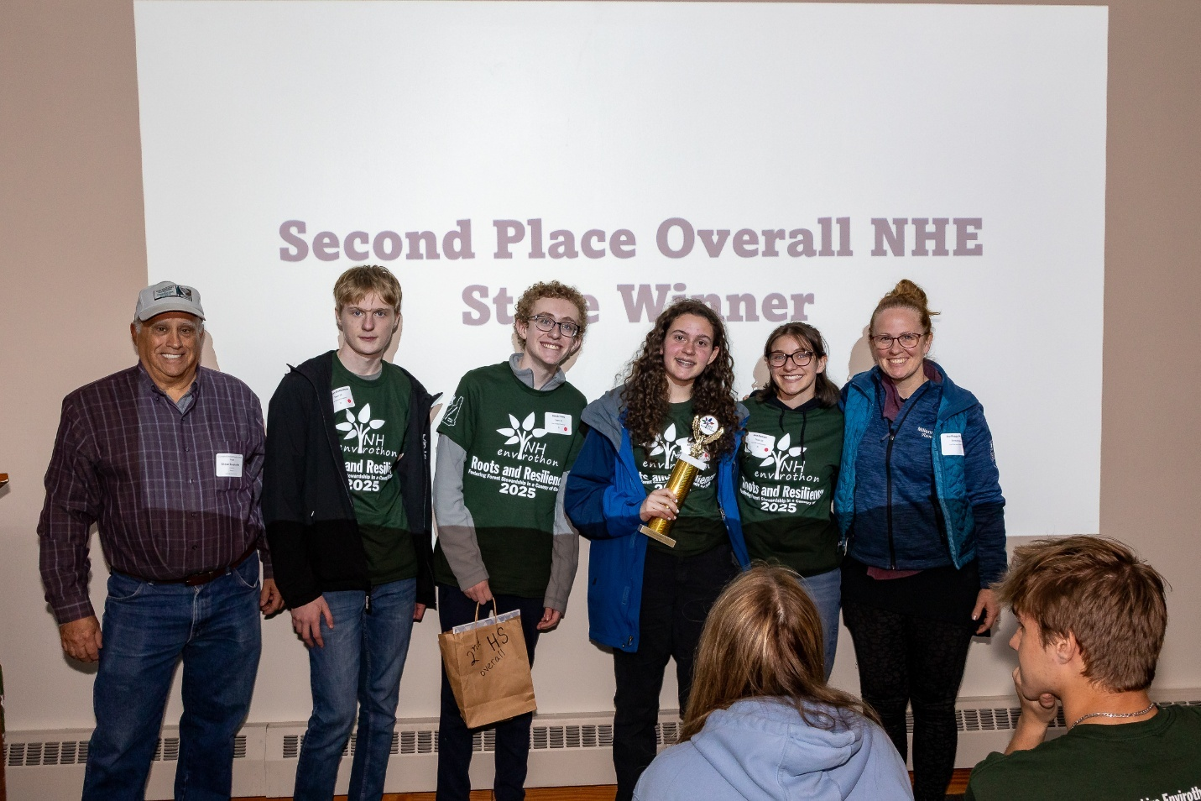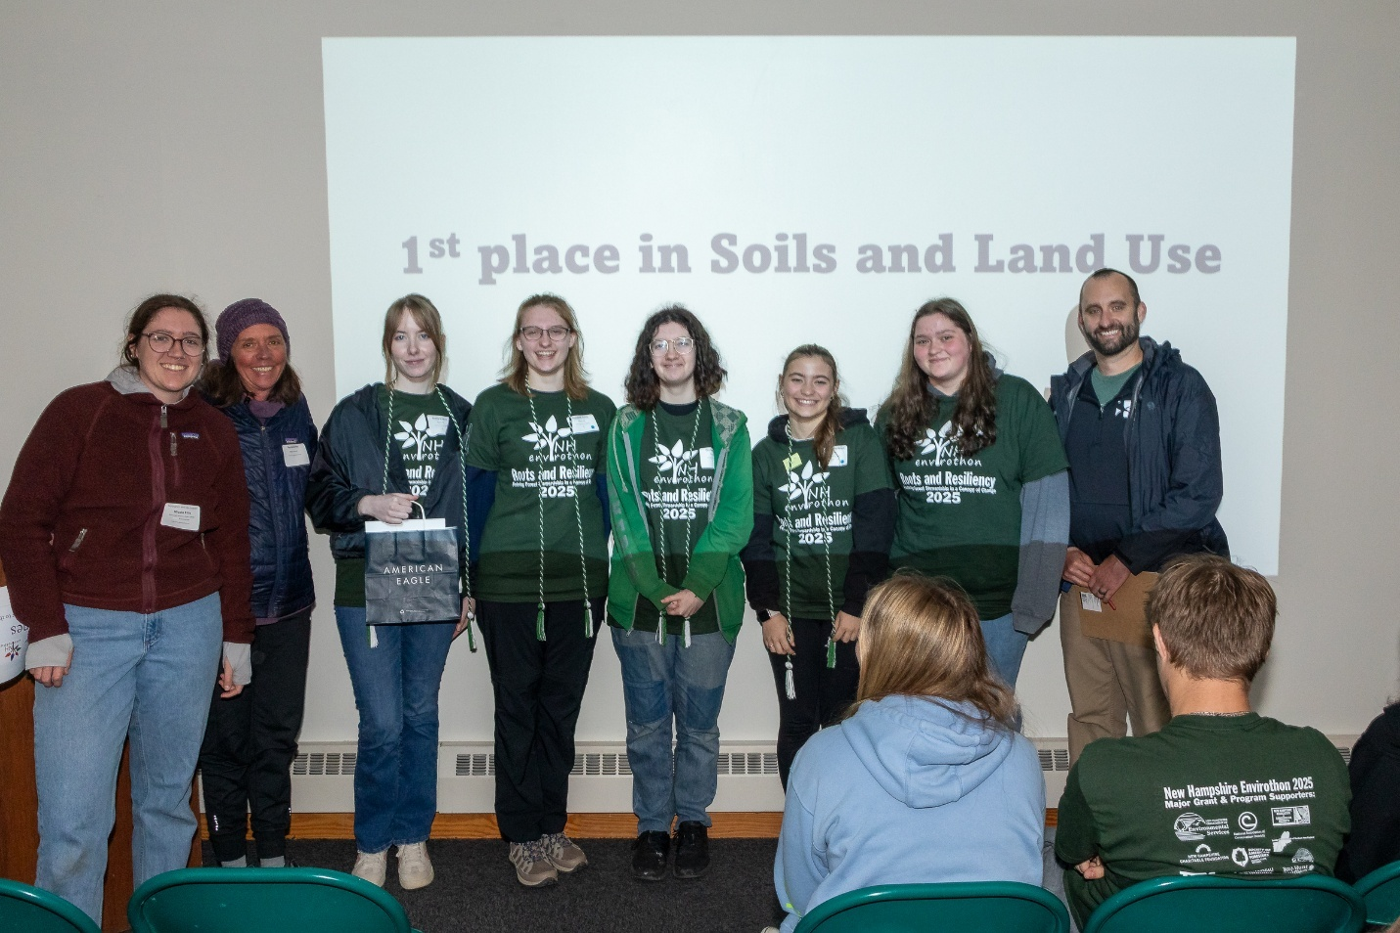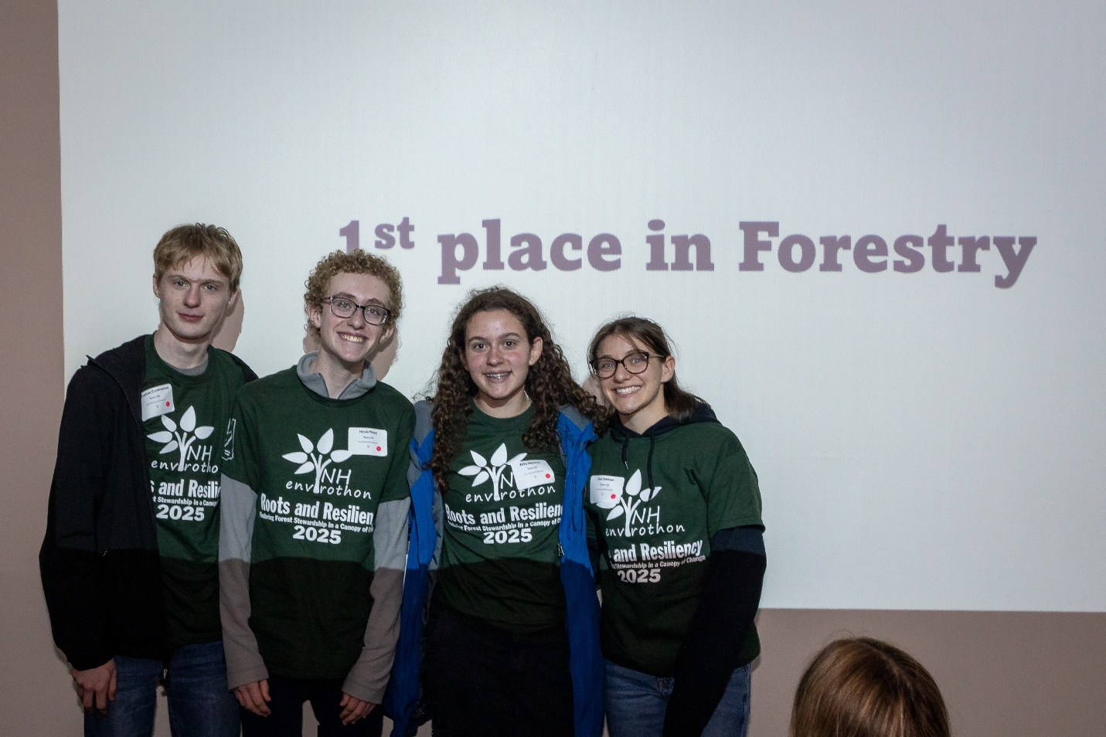
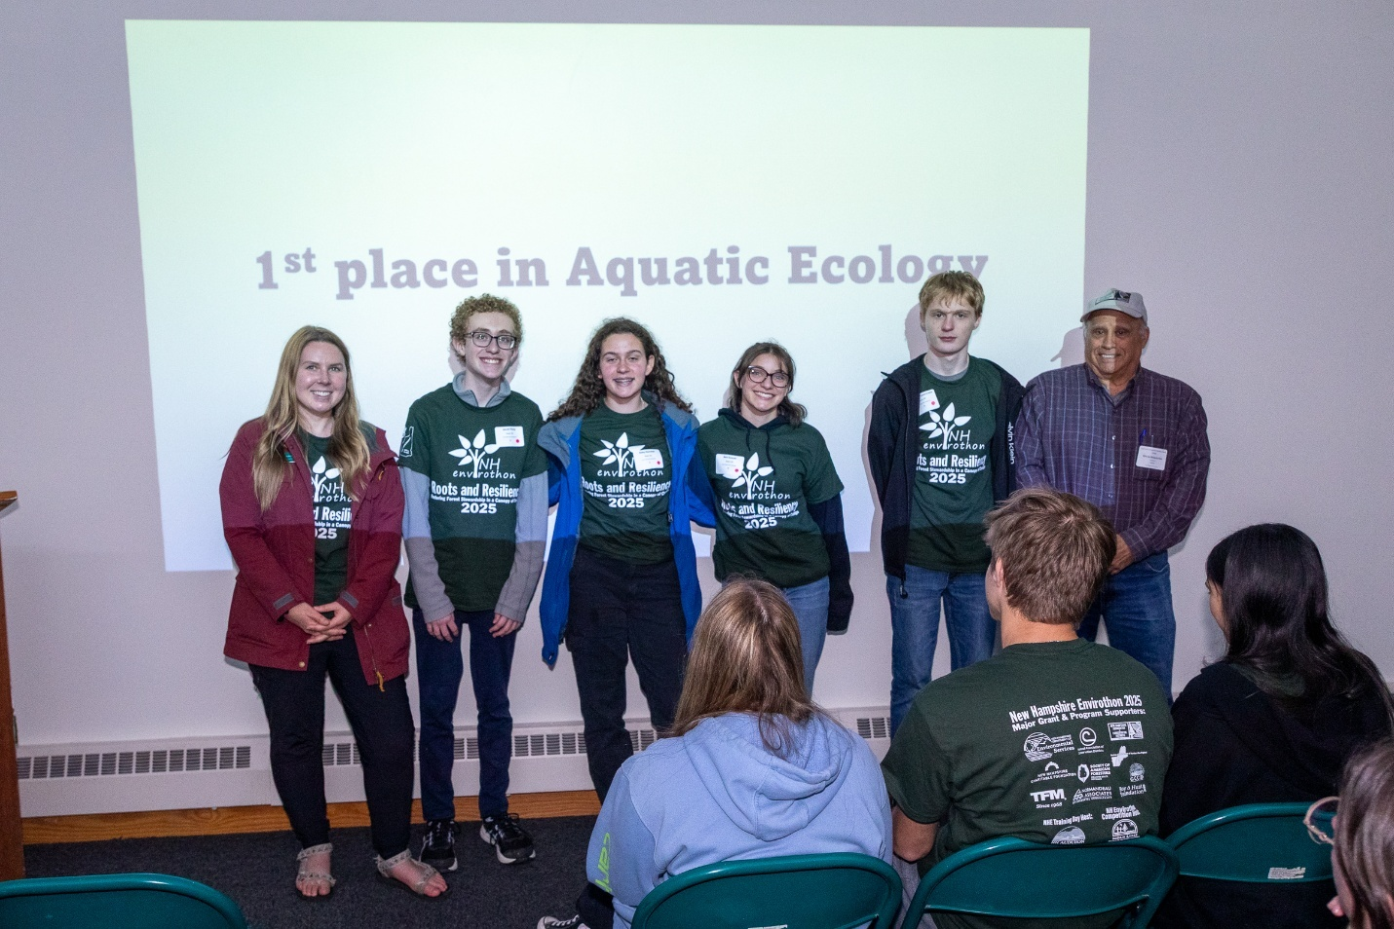

*Unfortunately, Goffstown HS and Moultonborough MS had to leave before the awards.

NHE Volunteers 2025
Name | Title | Organization
Aquatic Ecology
Kayla Marshwood | Watershed Education Specialist | NH Fish and Game
Judy Tumosa | Environmental Specialist and Educator | NH Fish and Game, retired
Bob Craycraft | Lakes Monitoring Program Coordinator | University of New Hampshire
Ken Kettenring | Wetlands and Hazardous Waste Remediation | NH Dept of Environmental Services (retired);
Lara Hooper | Drinking Water & Groundwater Education Coordinator & NH Project WET Coordinator | NH Department of Environmental Services
Forestry
Ian Aldrich | Consulting Forestry Technician | Martin Forestry
Kyle Lombard | Forest Health Program Coordinator | NH Dept. of Natural & Cultural Resources
Josh Levesque | Forester | US Army Corps of Engineers
Samantha Schupp | Park Ranger | US Army Corps of Engineers
Luke Berardinelli | Central Region Forester | Division of Forests and Lands
Leo Maslan | Wood Procurement Forester | Finch Paper LLC, Glens Falls, NY
Soils and Land Use
Nicole Ellis | Soil Scientist | NRCS
Josh Gaimaro | Soil Scientist | Soil Scientist, USDA-NRCS
Peter Whitcomb | Soil Scientist | USDA-NRCS, retired
Lucy Zendzian | Soil Scientist | USDA-NRCS
Maddy Czymmek | Soil Scientist | Forest Service
Wildlife
Lindsay Webb | Wildlife Educator | NH Fish and Game
Maria Colby | Director | Wings Wildlife
Claire Adams | Environmental Educator | NH Audubon
Thaddeus Kendziora | Wildlife Biologist | US Fish and Wildlife Service
Leigh Ann Reynolds | Administrator | NH Environmental Educators
Current Issue Judges
John Slater | Earth Science Adjunct | UNH
Gabe Roxy | NRCS State Forester | USDA National Resources Conservation Service
Steve Roberge | State Extension Forester | UNH Extension
Pat Martin | Electrical Engineer, Patent Developer | Wang Laboratories, retired
Ralph Pisapia | Assistant Regional Director – Ecological Services, retired | U.S. Fish & Wildlife Service
Steve Scapicchio | President | NHACD
Kerry Rickrode | District Manager | Hillsborough County Conservation District
Pam Gilbert | District Manager | Grafton CCD
Caelin Graber | Instructor | Harmony Health Institute, Merrimack, NH
John McCarthy | Water Resources Professional | EPA Environmental Finance Advisory Board, retired
Stacy Luke | District Manager | Merrimack County Conservation District
John Lambert | Director | Biodiversity for a Living Climate
Russ St. Pierre | Environmental Manager | NH Department of Transportation, retired
Grace McEachern | Conservation Technician | Rockingham County Conservation District
Paddy McCarthy | World Language Instructor | HS and College, retired
Bill Hauser | Environmental Manager | NH Department of Transportation, retired
Sydney Paradise | Squam Lakes Association  AmeriCorps Member | Lakes Region Conservation Corps
Fay O'Toole | Squam Lakes Association  AmeriCorps Member | Lakes Region Conservation Corps
Corbin Faidley | Squam Lakes Association  AmeriCorps Member | Lakes Region Conservation Corps
Sue Moore | Teacher Naturalist | Massachusetts Audubon
Heather Bryant | Field Specialist, Food and Agriculture | UNH Cooperative Extension
Megan Heidenreich | Teaching Lecturer | Plymouth State University
Snack and drink coordinator | Kathryn Manning | Keene State College Librarian, retired
Greeter | Jan Hooper | Coordinator Director, Belknap CCD ret.
NHE Photographer
Jeremy Fowler | Jeremy Fowler | Jeremy Fowler
Tabitha Edwards | Tabitha Edwards | Tabitha Edwards
 | Group Leaders
Bev Hart | Mathematics Educator | High School, retired
Debbie Claflin | Mathematics Educator | Middle school, retired
Rob Traver | Environmental Educator | WPI, retired
Sarah McGraw-Small | Soils Conservationist | NRCS, USDA, Epping Office
Avis Baker | Conservation Planner | NHACD
Ryan Crawford | Volunteer | Sullivan County Conservation District
Eric D'Aleo, Victoria Brown, or Drew Stazesky | Naturalist | Squam Lakes Natural Science Center
Sam Higginbottom | Conservation Technician | Rockingham CCD
Kelley Lavoie | Assistant Naturalist | Squam Lakes Natural Science Center
Alex Bradley | Assistant Naturalist | Squam Lakes Natural Science Center
Scorers
Emily Fernald | Assistant District Manager - Operations | Rockingham CCD
Bev Hart | Mathematics Educator | High School, retired
Score Runners
Kim Kapteyn | Voluntee  Administrative Assistant | Sullivan CCD,  Microbiotix, retired
Jordan Fritz | District Manager | Carroll CCD
Squam Lake Natural Resource Center Coordinators
Audrey Eisenhauer | Senior Naturalist | Squam Lakes Natural Science Center
Melissa Greenawalt | Naturalist / Camp Coordinator | Squam Lakes Natural Science Center
Squam Lakes NSC Animal Ambassadors
Eric D’Aleo  1 - Importance of Habitat to Animal Survival | Naturalist | Squam Lakes Natural Science Center
Drew Stazesky  2 - Adaptations for Animal Survival | Naturalist & Camp Coordinator | Squam Lakes Natural Science Center
Audrey Eisenhauer  3 - Human Impacts to Wildlife & Wildlife Conservation Actions | Senior Naturalist | Squam Lakes Natural Science Center
Margie Clark-Kevan | Program Coordinator | NH Envirothon
Lucas Goldfluss | Program Coordinator | Vermont Envirothon
Award Reader | John Slater
Senior honor cord award presenter | Jan Hooper | Coordinator Director
Feedback & Top Content Award Presenters
Aquatic Ecology | Kayla Marshland | Watershed Education Specialist
CEI | John Slater | Earth Science Adjunct
Forestry | Ian Aldrich | Consulting Forestry Technician
Soil & Land Use | Nicole Ellis | Soil Scientist
Wildlife | Lindsay Webb | Wildlife Educator and Leader
Top overall awards | Steve Scapicchio | President

