New Hampshire Envirothon
“Invasive Species”

Aquatics Exam – Middle School
May 24, 2016

Figure 1 Eurasian water-milfoil

Please give complete and concise answers, and provide sound rationale for each. Good luck!!

Theme #1: Invasive Species Management (25 points)

Muddye Pond is located in My Backyard, NH. It is a popular summer vacation spot for tourists and the locals enjoy year round recreational activities in and around the pond. Muddye Pond characteristics:
- 20 acres in size
- 25’ deep at the deepest point
- Lots of shallow water edge habitat with native aquatic plants
- Spring fed with no outlet
- Healthy population of largemouth bass

Muddye Pond has an infestation of Icky Weed, which is recognized as an invasive species of algae.

Options for control include:
- Use the fish species Common carp Cyprinus carpio to eat it
- Use herbicides to kill it
- Drain and dredge, then re-fill the pond
- Do nothing

Explain which option(s) for control you think each of these people would prefer to use and why.

- You are on the Conservation Commission and support the natural functions of all aquatic ecosystems. (13 points)

- You are a landowner and have the Icky Weed in front of your dock. You also love to fish for bass.
(12 points)

Theme #2: Invasive Species Identification (25 points)

- “If it makes me happy, why the heck are you so sad?” Cheryl Clough asks her biology teacher as they look out over the sea of purple. “It’s the prettiest wetland I’ve ever seen.”

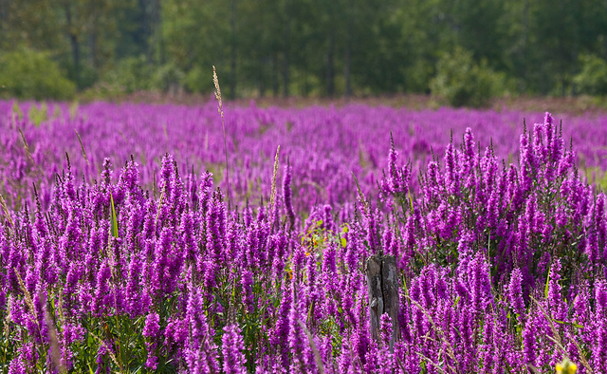

- What is the name of this plant? (3 points)

- What are the environmental impacts that make Cheryl’s teacher so sad? (7 points)

- For each of the following plants indicate whether they are native or Exotic and invasive or non-invasive by putting an X in the appropriate box. (15 points)

Plant | Native | Exotic | Invasive | Non-invasive
Cattails
Pickerel weed
Milfoil
Lilac
Phragmites
Poison Ivy
Honeysuckle

Theme #3: Biological Sampling (25 points)

Date | Temperature  (ºC) | Dissolved  Oxygen  (mg/L) | Specific  Conductivity  (uS/cm) | Turbidity  (NTU) | Total  Phosphorus  (ug/L)
4/12/16 | 9 | 11 | 54 | 2 | 8
4/19/16 | 11 | 11 | 52 | 1 | 7
4/26/16 | 13 | 9 | 51 | 22 | 122
5/3/16 | 14 | 10 | 51 | 5 | 17
5/10/16 | 15 | 10 | 52 | 1 | 7
5/17/16 | 16 | 9 | 52 | 1 | 8

As members of your Town’s conservation commission, you have been monitoring the Meandering River immediately downstream of Old Timer Fred’s family farm for the past several years. The objective is to generate a baseline dataset that would characterize the current condition of the river and could be used to screen for potential problem areas. During your May 20 Conservation commission meeting, a resident alleged that Old Timer Fred was using mechanized equipment, on his property, to dredge the stream and to skim the topsoil from the riparian zone in an attempt to remove that pesky Purple Loosestrife. Before approaching Old Timer Fred and before contacting the state environmental officials, you have decided to look at some of the recent physical, chemical and biological data that have been collected. Please answer the following questions and be sure to justify your answers.

Are there any measurements collected between April 12 and May 17 (refer to table above) that suggest some type of land disturbance in/adjacent to the river? Fill in the table to support your answer. (15 points)

Measurement | Importance to water quality monitoring | Suggests land disturbance (yes/no)
Temperature
Dissolved Oxygen
Specific Conductivity
Turbidity
Total Phosphorus

You have macroinvertebrate samples from May 10, 2015 (Tray A) and May 10, 2016 (Tray B).

Based (only) on the macroinvertebrate data presented in Trays A and B, can you conclude that the water quality has changed? Discuss the concepts of biological diversity and pollution tolerance, as they relate to water quality assessment, when justifying your answer. (10 points)

Justify your answer:
The water quality has (check the appropriate choice):

_____ improved
_____ declined
_____ remained the same

Theme #4: Invasive Species Impact (25 points)

- Please describe how invasive aquatic plant species affect the following aspects of living in New Hampshire. (5 points each)

  - Recreation

  - Human health

  - Lakes, ponds, rivers and stream ecology

Area 51 Lake, located just below Muddye Pond, has been found to have invasive aquatic species. There’s a dam on this beautiful, yet mysterious lake that the abutters have mixed emotions about. Some say the dam helps while others say it hinders the control of the invasive species. The dam is in poor condition and there has been talk of possible removal. The Dam Committee wants your input!

Please place a “X” next to your answer choice of T or F: (1 point each)

- Dams are an easy way to confine invasive vegetation and species to one waterbody: ____ T ____ F
- For a winter drawdown to be most effective it should only last a short time: ____ T ____ F
- A winter drawdown has only a positive effect on controlling invasive vegetation and
will not affect any of the other vegetation: ____ T ____ F
- A winter drawdown should not occur very frequently as it will cause the invasive
species to rebound faster: ____ T ____ F
- A winter drawdown can freeze the sediment causing damage or death to aquatic
vegetation: ____ T ____ F

Should the dam be repaired or removed and explain your reason. (5 points)

 Do not put your team number on this page!

 Please give us some feedback, it does not count towards the final grade.

How do you rate this exam? (check off the appropriate descriptor below)

Impossible ____

Difficult _____

Just Right _____

Too Easy _____

Other _____ (please explain)

If you’ve taken past Aquatics tests at Envirothon, was this test:

Better _____

The Same _____

Worse _____

Good luck with the rest of the day!

